0TITLE 

Department of Information Technology

COLLEGE OF ENGINEERING

CENTRAL LUZON STATE UNIVERSITY

Science City of Muñoz, Nueva Ecija

CLIRDEC: PRESENCE – PROXIMITY AND RFID- ENABLED SMART ENTRY FOR NOTATION OF CLASSROOM ENGAGEMENT

A Capstone Project

Presented to the

Department of Information Technology

In Partial Fulfillment

of the Requirements for the Degree

BACHELOR OF SCIENCE IN INFORMATION TECHNOLOGY

By:

Feria, Matt Calgae S.

July 2025

DISCLAIMER

“This Capstone Project is submitted to the Department of Information Technology, College of Engineering, in partial fulfillment of the requirements for the degree Bachelor of Science in Information Technology at the Central Luzon State University, Science City of Muñoz, Nueva Ecija. It is a product of our work except where indicated in the text. The project report or any portion thereof, including the source code, or any section, may be freely copied and distributed provided that the source is acknowledged.”

APPROVAL SHEET

This capstone project proposal entitled “**CLIRDEC: PRESENCE - PROXIMITY AND RFID- ENABLED SMART ENTRY FOR NOTATION OF CLASSROOM ENGAGEMENT**” prepared and submitted by **MATT CALGAE S. FERIA** in partial fulfillment of the requirements for the degree BACHELOR OF SCIENCE IN INFORMATION TECHNOLOGY, has been examined and is hereby endorsed.

**MS. MARYCRIS A. MANALANG**

Adviser

CAPSTONE 1 PROJECT ORAL PRESENTATION COMMITTEE

|  |  |  |
| --- | --- | --- |
| **MS. ANGELIKA S. BALAGOT** |  | **MR. RYAN L. BERMOZA** |
| Chair |  | Member |
|  |  |  |
| Date Signed |  | Date Signed |

Accepted and approved in partial fulfillment of the requirements for the degree BACHELOR OF SCIENCE IN INFORMATION TECHNOLOGY, school year 2024-2025.

**DR. ANJELA C. TOLENTINO**

Head, Department of Information Technology

_______________

Date Signed

**DR. ROY SEARCA JOSE P. DELA CRUZ**

Acting Dean, College of Engineering

_______________

Date Signed

CERTIFICATION OF MANUSCRIPT PROOFREADING

This is to certify that the undersigned has reviewed and edited the manuscript of **MATT CALGAE S. FERIA**, entitled **"** **CLIRDEC: PRESENCE – PROXIMITY AND RFID- ENABLED SMART ENTRY FOR NOTATION OF CLASSROOM ENGAGEMENT"**. This further certifies that the scope of editing is for proper English language, grammar, punctuation, spelling, and overall writing style.

Issued this 23rd day of June, 2025, at Munoz National High School.



**JUN FRANCIS P. SANTIAGO**

Master Teacher I

Muñoz National High School Main JHS

ABSTRACT

Attendance monitoring is still an important part of classroom management and ensuring academic accountability in most higher education institutions such as Central Luzon State University (CLSU). Attendance-taking through manual means has been practiced for so many years but has challenges such as inconsistency in recording, delay in documentation, and unintentional mistakes. There are also problems like falsified attendance also known as "ghost attendance", which can introduce inaccuracies in academic records and threaten the transparency of learning environments.

In response to these concerns, this study proposes CLIRDEC: PRESENCE - Proximity and RFID-Enabled Smart Entry for Notation of Classroom Engagement. The system is designed as an Internet of Things (IoT)-based solution tailored for the Bachelor of Science in Information Technology from the Department of Information Technology (DIT) under the College of Engineering at Central Luzon State University. By integrating RFID-based tap logging with proximity sensors, the system verifies not only student identity but also their physical presence within the classroom. Data collected during tap-in and tap-out events are validated in real time using motion detectors and are transmitted via an ESP32 microcontroller to a cloud-based MySQL database. A Phython-powered backend and a Bootstrap-based frontend provide faculty and administrators with access to real-time dashboards, attendance summaries, and discrepancy notifications.

The development of the system follows the agile methodology using the scrum framework for continuous iterative improvements based on what the users told. CLIRDEC: PRESENCE greatly aims to support faculty in managing attendance-efficiently through a secure and fully automated approach while still ensuring integrity and reliability within the Department of Information Technology. This project exemplifies how the mindful application of IoT impacts a brighter, cleaner, and more tech-supported academic environment.

TABLE OF CONTENTS

**INTRODUCTION 1**

**PROBLEM STATEMENT 3**

**General Problem 3**

**Specific Problem** 3

**OBJECTIVES 4**

**General Objective 4**

**Specific Objectives** **4**

**SCOPE AND LIMITATION 4**

**Scope 5**

**Limitations 6**

**SIGNIFICANCE OF THE STUDY 7**

**Stakeholders 7**

**Future Researchers** **8**

**DEFINITIONS OF TERMS 9**

**REVIEW OF RELATED LITERATURE AND EXISTING ALTERNATIVES 11**

**Introduction 11**

**Gaps in Existing Research 16**

**Conclusion 22**

**METHODOLOGY 24**

**Research Design 24**

**System Architecture/Conceptual Framework 25**

**Development Tools and Technologies 28**

**Algorithms and Techniques 29**

**Implementation Process 30**

**Data Collection and Processing (If Applicable) 37**

**Testing and Evaluation 38**

**Ethical Considerations (If Applicable) 41**

**LIST OF FIGURES**

Figure No. Title Page

1 System Architecture Diagram ………………………………………………… 42

2 Entity Relationship Diagram……………………………………………………43

3 Flowchart Diagram……………………………………………………………...44

4 Use-Case Diagram………………………………………………………………45

5 Agile Development Lifecycle…………………………………………………...31

6 Scrum Framework……………………………………………………………….32

**LIST OF TABLES**

Table No. Title Page

1. Gaps in Research Design……………………………………………………….16
2. Table Checklist………………………………………………………………….20

## INTRODUCTION

Currently, educational institutions are increasingly adopting digital technologies, especially smart systems, to enhance administrative and instructional processes. Among these advancements is the trend of using IoT-based systems, especially in attendance monitoring.

In the Department of Information Technology, attendance in the classrooms and laboratories is taken manually to a great extent, printing lists for students to sign in or verbally calling out names. This method is traditional and time-consuming, with immense probability for human errors due to wrong entries, omissions, and late validation. In consequence, this would sometimes lead to incomplete or inaccurate records, making it hard for faculties to track the students' attendance perfectly and timely. With the ever-expanding academic institutions and increase in the number of students per class, the call for some sort of automation for real-time checking and validation of attendance is getting louder.

Attendance systems require supervision in real time in cases which have become even more pertinent to institutions that are currently growing, according to the assertion made by Krishna et al. (2023) that a lot of inconsistencies in manual attendance systems occur in records. Hayati and Nugraha (2023) agreed with the sentiment that manual methods fall short of precluding students from ghost attendance behavior—actual students are marked present while absent—such occurrences take place in big classes and laboratory settings where it is hard to monitor students closely.

In relation to these deficiencies, the system will significantly help the professors from the DIT under the College of Engineering at CLSU, who keep busy stuffed, ever-increasing schedules accompanied by the ever-expanding student population. Without adopting any form of automation, faculties find it difficult to pinpoint late arrivals, unauthorized exits, or habitual absentees. Furthermore, manually handling attendance records takes painstaking hours of instructional learning for administration duties.

Hence, the PRESENCE system will be proposed, which stands for "Proximity and RFID Enabled Smart Entry for Notation of Classroom Engagement." It makes use of Radio Frequency Identification and proximity sensor technologies for automatic real-time classroom activity monitoring. This will involve students tapping RFID cards when entering and leaving the classroom; this would then be validated by proximity sensors. The result will be precise automated records available in real time to faculty via web dashboard for more administrative implementation efficiency, data correctness, and accountability of the entire academic setting.

# PROBLEM STATEMENT

## General Problem

The College of Engineering's CLIRDEC building maintains attendance recording in the usual manual way, via sign sheets and roll-calling students by their voices. Such methods are outdated, ineffective, and error-prone; they fall under manipulation modes like ghost attendance or false logs. Therefore, faculties have to put in a lot of effort to record accurate student presence, generate timely reports on attendance, and manage student accountability in class. The institution sorely lacks a reliable real-time attendance system that has a huge impact on the quality of instruction.

**Specific Problems:**

1. **Manual Attendance Records/Tracking:** As for attendance taking a manual process, attendance records are most of the time duplicated or omitted leading to inaccuracy that affects the credibility of the attendance record. In addition, a manual process for students' attendance using the available instructional period leads to an increased workload on the faculty in data management rather than spending it on teaching.
2. **Ghost Attendance:** This occurs when students are actually not present in class but are marked as present, thus unduly affecting the quality of attendance records.
3. **Inefficient Monitoring Laboratory Classes:** Without an automated monitoring system of laboratory classes provers manually rather difficult to access unauthorized computer usage, access to restricted files, etc. and all that non-academia related activities with delay. This clearly identified one of the cases of automation use in upholding classroom integrity.
4. **Delayed Access to Attendance Reports:** Since such attendance processing is manual, therefore the information will not be available for timely intervention and decision-making.

# OBJECTIVES

## General Objective

## The project intends to design and implement an IoT attendance monitoring system for the CLIRDEC building under the College of Engineering at Central Luzon State University that would employ RFID technology and proximity sensors in automating, validating, and streamlining the recording and reporting of student attendance.

## Specific Objectives

* To develop and implement an RFID- and proximity-based system with a web dashboard for accurate, automated student attendance tracking that reduces faculty workload.
* To prevent ghost attendance by validating the physical presence of students through integrated RFID and proximity detection during classroom entry and exit.
* To incorporate monitoring features that allow instructors to flag unethical behaviors in laboratory classes, such as unauthorized computer use and access to restricted files, during active sessions.
* To generate automated downloadable attendance reports that provide access to student logs for timely academic interventions and verification of records.

# SCOPE AND LIMITATIONS

The project will be an IoT-based attendance monitoring system specifically develop for Bachelor of Science in Information Technology students from the Department of Information Technology (DIT) under the College of Engineering at Central Luzon State University. The attendance system called CLIRDEC: PRESENCE, which stands for Proximity and RFID-Enabled Smart Entry for Notation of Classroom Engagement, will provide automatic attendance recording through the use of RFID technologies and proximity sensors to ascertain student presence. The system will be designed to meet present challenges involving ghost attendance, manual record keeping, and time-consuming manual processes. The proposed IoT attendance system will enable real-time monitoring and validation data and automated reporting in support of classroom management and institutional efficiency. It stands as an expandable prototype for future adoption in other departments or colleges of the university.

**Scope**

The scope of the system will include the following features:

* **Testing and Deployment Coverage:** The system will be deployed across ten (4) selected classrooms that will include five (2) lecture rooms and five (2) laboratory rooms within the CLIRDEC building. Each room will monitor attendance for students using RFID-enabled ID cards.
* **RFID-Based Entry Logging**: Individual student RFID cards will be used to tap into as well as tap out of the proper classrooms and laboratories, which will thereby automatically log attendance.
* **Proximity Sensor Validation**: Near the RFID scanner, a motion or body sensor will be installed to verify whether a student enters or exits the place; thus, it could deduce and activate whether he is present physically or not.
* **Real-Time Attendance Dashboard**: With the help of this, faculties can see or monitor the real-time attendance of students without a hitch through a web-based interface.
* **Automated Attendance Reports**: At the end of every class, the system would automatically generate a downloadable report of the attendance summary with time stamps and entry/exit status at the end of every class.
* **Cloud-Based Database**: All this log would be stored in a common cloud-hosted database so that it could be secured, back-up, and accessed easily.
* **Role-Based Access Control**: As far as the roles are concerned, this system would differentiate its user roles; that is, the different roles from a user could be - faculty can view reports and attendance logs, while administrators can configure system settings and manage registered users.

**Limitations**

Despite its potential, the system will have the following limitations:

* **CLIRDEC-Specific Deployment**: Implementation of the system was initially limited to the CLIRDEC building and not set for other colleges or departments during pilot testing.
* **RFID Dependence**: The system can be accessed only for students with issued RFID cards. Lost and unregistered cards will impact data accuracy.
* **Sensor Accuracy Constraints**: The proximity sensor may sometimes fail to detect presence due to hardware limitations, resulting in RFIDs mismatch lapses.
* **Internet Reliance**: The system will require a stable internet connection in order to be able to synchronize data in real-time and access the dashboard; offline not supported.
* **No Biometric Integration**: The current scope does not include fingerprint or face recognition technologies for an additional validation of presence.
* **Maintenance Exclusion**: This capstone project is limited to developing, implementing, and demonstrating key features. System maintenance, hobby upgrades, and technical support, however, are outside the current research scope.

**SIGNIFICANCE OF THE STUDY**

The implementation of CLIRDEC: PRESENCE-a monitoring-attendance system based-on IoT has brought tremendous advantages to a number of stake holders from the academic community of the Central Luzon State University's (CLSU) College of Engineering, particularly, the CLIRDEC building. It fixes time-worn problems with manually taking attendance, being supple, automatic, and safe, and increasing the accuracy of results and accountability and improved administrative performance.

* **Information Technology Students**

The system is fair and transparent; only those physically able to be present in the classroom will be marked present. This promotes academic integrity and encourages responsible attendance behavior by the students.

* **DIT Faculty Members**

The system would mean less work for the faculty, with recording and reporting of attendance being automatic and allowing the faculty not to worry about manual documentation, instead spending more time on instruction and engaging students.

* **IT Developers**

The project provides a pattern for bringing IoT technologies into academic settings. It propels continuous research and development in smart campus systems, application of the IoT, and educative technology.

* **Researchers**

The study provides a valuable reference for researchers working on student tracking, automated classroom systems, or the integration of IoT technologies in academic environments. Through its emphasis on timely, accurate attendance monitoring, CLIRDEC: PRESENCE supports CLSU’s advancement toward a more digitally transformed and efficient smart campus.

* **Future Researchers**

The study would act as a reference for future research and system development pertaining to students' tracking, automated classroom functionality, or the proliferation of IoT-based applications in higher education settings. By ensuring systematic on-time monitoring and accurate attendance, CLIRDEC has a digital transformation contribution for CLSU, putting it towards a much higher step as far as the smart and efficient academic institution is concerned.

**Definition of Terms**

**CLIRDEC: PRESENCE –** Proximity and RFID-Enabled Smart Entry for Notation of Classroom Engagement. It is the IoT-based attendance monitoring system developed in this study for the CLIRDEC building.

**RFID (Radio Frequency Identification) –** A wireless technology that enables identification through electromagnetic fields. In this study, RFID is used to log student attendance through tap-in and tap-out actions.

**RFID Card –** A card embedded with a chip and antenna used by students and faculty to record their entry or exit from the classroom.

**Proximity Sensor –** An electronic sensor used to detect human presence. In the system, it validates whether a person is physically present during an RFID tap.

**ESP32 –** A microcontroller that processes data from RFID readers and proximity sensors, transmits data to the backend, and handles wireless communication.

**IoT (Internet of Things) –** A network of physical devices embedded with sensors and software that collect and exchange data over the internet. This project is based on IoT principles for real-time attendance tracking.

**Dashboard –** A web-based interface that displays real-time attendance logs, reports, and flagged discrepancies. Used by faculty and administrators.

**Cloud Database –** An internet-hosted storage system that manages and stores RFID logs, session schedules, and attendance data securely and accessibly.

**Ghost Attendance –** A case of academic dishonesty where a student is marked present despite being physically absent, usually due to manipulation of manual records.

**Discrepancy Detection –** A system function that flags inconsistencies between RFID logs and proximity sensor data, helping detect ghost attendance.

**Real-Time Monitoring –** Continuous tracking of attendance events as they occur, allowing immediate logging, validation, and alerts.

**Role-Based Access Control (RBAC) –** A system feature that restricts user permissions based on assigned roles (e.g., admin vs. faculty), ensuring data confidentiality and access control.

**Agile Methodology –** An iterative development approach used in this project to gather feedback regularly and improve the system incrementally.

**SCRUM –** A subset of Agile, applied here to manage project tasks, sprints, and team collaboration for efficient system development.

**Tap Event –** An RFID-based action where a student or faculty taps their card on the scanner to log entry or exit.

**Discrepancy Flag –** A system-generated alert triggered when RFID logs do not match proximity sensor data, indicating potential anomalies.

**Session –** A time-bound classroom schedule initiated and ended by an instructor’s RFID tap to ensure that attendance is recorded within valid periods.

**Attendance Log –** The official digital record of a student’s entry and exit, timestamped and validated, stored in the system database.

## REVIEW OF RELATED LITERATURE

## AND EXISTING ALTERNATIVES

The growing adoption of Internet of Things (IoT) technologies in educational institutions is pushing for the development of smart classroom management solutions for better efficiency. Some of the core issues that end-to-end IoT solutions address include attendance maintenance, conservation of energy, and security. Recent research has gone a long way in proving beyond doubt the feasibility and, to some extent, success of IoT systems in the education environment like CLIRDEC: PRESENCE.

**IoT-Based Attendance Systems**

Several studies have supported the need for intelligent attendance systems in academic institutions. Krishna et al. (2023) highlighted the operational challenges posed by human error in manual logging and proposed automated solutions to reduce inaccuracies. Their study emphasized how real-time validation mechanisms can address integrity issues in attendance monitoring.

Hayati and Nugraha (2023) introduced a proximity-based attendance system to reduce ghost attendance. Although their system used physical sensors, the principle of validating actual presence aligns with PRESENCE’s facial recognition mechanism.

Hussien et al. (2024) further investigated the amalgamation of monitoring and attendance with an emphasis on the auxiliary values of linking surveillance features with automated reporting. This is an affirmation of the central idea of PRESENCE, which maintains the use of cameras as both secure devices and attendance registers. The work by Ishaq and Bibi (2023) also dedicated itself to conducting a literature review on smart attendance systems and elaborated on the merits of scalable and integrated platforms in the cloud as relevant tools for real transparency and accessibility. Therefore, such ideas inform the design of features such as the PRESENCE cloud dashboard and data access.

In addition, Valdez et al. (2024) proposed TrackID, an RFID-based student monitoring system designed for executing access control and attendance regulation to campuses. Their system aims to ensure that only authorized individuals can access a restricted area, similar to PRESENCE, which restricts classroom access and energy control to verified faculty and enrolled students.

Shoewu et al. (2022) took this concept further with the design of SMAT-NFC, which is a smart attendance system employing near-field communication. Their system proved that contactless authentication can aid attendance and minimize physical infrastructure requirements. While CLIRDEC: PRESENCE utilizes RFID instead of NFC, it shares the same purpose of automated, contactless attendance logging.

Verma et al. (2022) further discussed an RFID-based attendance marker that aims to enhance the efficiency of the institution by removing manual entry errors. Their work upholds the basic premise of PRESENCE: that automating attendance not only makes it time-efficient but also ensures accurate and authentic student records.

Abellana et al. (2022) elaborated on this by integrating GSM notifications to their Arduino-based RFID attendance system. Their system allows real-time updates to the stakeholders, which certainly holds future opportunities for enhancing the PRESENCE, including the option of sending some alert notifications to faculty or administrators in case there is a mismatch between sensor and RFID data.

**Facility Access and Security Integration**

Rahman et al. (2021) refer to the IoT-based surveillance systems for smart campuses, pointing out the necessity of integrating existing access and attendance systems with surveillance. Moreover, it argued that detection mechanisms should be integrated with analytics and control systems, which is precisely how PRESENCE works by marking unauthorized exits through contradictions in sensor data contrasted with attendance logs.

## In their turn, Boudhir et al. (2023) pointed out that an efficient smart campus must feature layered digital infrastructure that encompasses access control, real-time surveillance, and automated alerts. PRESENCE combines facial recognition and cloud-based authentication to monitor movement, enhance situational awareness, and provide security in classrooms, paralleling these aspects.

## Ahmed and Mazri (2023) offered an insight into smart campus security strategic issues and the need for entries being validated as secure and logged access events incorporated into PRESENCE identity verification and the logging mechanisms.

**Local Studies in the Philippines**

Several research studies conducted in the Philippines have given evidence of increasing interest towards the automation of classroom attendance using IoT and smart technologies. One such research is that of Isabela State University-Cauayan City Campus, which proposed an IoT-based laboratory security facility realizing a RFID attendance authentication. The system was designed with utilization of security multiparty computation (SMC) and encryption algorithms to disallow impersonation and unauthorized access, which emphasizes the requirement of identity validation in attendance monitoring within laboratories (Alvarez et al., 2023).

7180 Ching holds in another project for the College of Information Technology and Engineering in Notre Dame of Midsayap; it has developed an RFID-based attendance system. It would try to solve problems regarding manual logging, like inaccuracy and inefficiencies of handling records. By automating check-in and connecting RFID cards into a centralized database, this system would deal with issues of accuracy in data housing and efficiency in administering such (Barrozo et al., 2024).

Pilar National Comprehensive High School, later developed a technological solution that involved the implementation of a facial recognition-attendance system and an automated records-management system. The study focused on reducing manual input errors while introducing real-time notification capabilities to inform parents and guardians of student attendance events. The integration of biometric features and communication tools aligns with the multi-layered authentication strategy proposed by CLIRDEC: PRESENCE (Grefaldo & Bausa, 2025).

Mapúa University advanced local attendance monitoring innovations through the development of an automated system integrating RFID, biometric verification, and GSM modem technologies. This multi-layered approach enabled real-time attendance tracking, improved security measures, and allowed immediate communication of attendance status to relevant stakeholders (Yumang et al., 2017).

National University–Laguna also contributed to the local development of smart attendance solutions through its mobile-based attendance monitoring system using Bluetooth Low Energy (BLE) technology. This Android-powered system automated attendance through wireless tethering, allowing for hands-free data capture and real-time verification of student presence (Dela Cruz & Santiago, 2023).

These local efforts underscore the feasibility of deploying IoT and RFID technologies in Philippine educational institutions. However, most systems are constrained by limited validation features, absence of role-based access control, and lack of classroom-specific automation. The proposed CLIRDEC: PRESENCE system addresses these gaps by integrating RFID-based identity verification with proximity detection, secure cloud-based storage, and real-time reporting within a role-restricted framework - tailored specifically for the CLIRDEC building of Central Luzon State University.

Saint Louis University (SLU) in Baguio City has implemented a campus-wide RFID-based system for student and personnel identification, which supports facility access, library services, and general record management. According to SLU’s official privacy policy, RFID technology may also be used for “recording… class attendance and participation in curricular” activities (Saint Louis University, n.d.). While there is no publicly available study confirming the full classroom deployment of RFID-based attendance tracking, SLU’s infrastructure demonstrates institutional readiness to support such systems. The integration of RFID into class attendance management is consistent with national trends toward contactless identification and smart campus systems.

The CLIRDEC: PRESENCE system advances this model by explicitly linking RFID tap events with proximity sensor validation to verify physical presence. Unlike SLU’s current generalized RFID usage, PRESENCE is classroom-specific, incorporates real-time dashboards, and flags attendance discrepancies-features aligned with modern instructional monitoring needs.

**Gaps in Existing Research**

*Table 1: Comparative Analysis of Previous Studies and Existing Alternatives in Attendance Monitoring Systems*

Table 1 presents the key findings and identified limitations of previous studies on automated attendance systems. While each solution demonstrates strength in specific features such as access control, contactless logging, or data automation, many lack dual validation, classroom-specific deployment, or real-time discrepancy detection. CLIRDEC: PRESENCE addresses these gaps by providing a classroom-focused, real-time IoT attendance system that integrates RFID tap logging with proximity sensor validation, role-based access, and automated reporting designed specifically for the needs of the CLIRDEC building at CLSU.

|  |  |  |  |
| --- | --- | --- | --- |
| **Research Title** | **Key Finding** | **Gaps/Limitations** | **Current Solutions to These Gaps** |
| **RFID-Based Student Monitoring System** (Valdez et al., 2024) | Uses RFID to control access and monitor attendance within the campus. | Does not verify physical presence; potential for ghost attendance. | PRESENCE integrates proximity sensors with RFID to validate physical presence. |
| **Proximity-Based Attendance System** (Hayati & Nugraha, 2023) | Uses physical sensors to confirm presence and reduce false logging. | Lacks multi-layer authentication and cloud integration. | PRESENCE combines RFID with proximity sensors for dual attendance verification. |
| **TrackID: RFID for Campus Security** (Valdez et al., 2024) | Ensures access control via RFID-verified entry points. | Focused on physical access; lacks classroom attendance features. | PRESENCE extends RFID functionality to classroom entry and attendance tracking. |
| **SMAT-NFC Attendance System** (Shoewu et al., 2022) | Implements NFC for contactless student attendance. | Requires device proximity but lacks dual-factor validation. | PRESENCE uses RFID plus proximity sensors to confirm presence before logging attendance. |
| **IoT-Integrated Smart Attendance System** (Krishna et al., 2023) | Automates attendance with IoT; reduces manual errors. | Does not prevent students from tapping in for others. | PRESENCE prevents ghost attendance by requiring both RFID and motion sensor validation. |
| **Arduino-GSM RFID System** (Abellana et al., 2022) | Sends real-time alerts to stakeholders using RFID. | Focused only on notification; lacks dashboard and local access logging. | PRESENCE features centralized dashboard with real-time logs and access verification. |
| **Smart Campus Security with IoT Surveillance** (Rahman et al., 2021) | Integrates security cameras with campus access systems. | Focuses on surveillance but lacks classroom-level control. | PRESENCE is classroom-focused with RFID and motion sensors for automated attendance logging. |
| **Smart Campus Infrastructure Layering** (Boudhir et al., 2023) | Recommends combining access control, monitoring, and alerts. | Limited examples of implementation in classroom settings. | PRESENCE applies infrastructure layering through role-based access, automation, and reporting. |

|  |  |  |  |
| --- | --- | --- | --- |
| **Role-Based Smart Attendance Platforms** (Park & Kim, 2021) | Proposes role-based user access to maintain data integrity. | Lacks implementation in public university settings. | PRESENCE applies role-based access (admin/faculty) for dashboard control and data management. |
| **IoT-Based Laboratory Security and Attendance Monitoring – Isabela State University** (Alvarez et al., 2023) | Utilized RFID-based authentication with secure multiparty computation (SMC) and encryption to prevent impersonation and unauthorized access. | Complex encryption approach may affect system usability and performance in real-time environments. | PRESENCE uses lightweight RFID + proximity sensor logic to streamline real-time validation. |
| **RFID-Based Attendance System – Notre Dame of Midsayap College** (Barrozo et al., 2024) | Improved data accuracy by automating attendance logging and centralizing records using RFID technology. | Lacked proximity validation and real-time anomaly detection. | PRESENCE addresses this by adding proximity sensors and discrepancy alerts. |
| **Facial Recognition-Based Attendance and Alert System – Pilar National Comprehensive High School** (Grefaldo & Bausa, 2025) | Reduced manual input errors and introduced real-time parental notifications. | Limited to high school context; lacks RFID and room-level automation. | PRESENCE focuses on RFID-based validation suitable for university classrooms. |
| **RFID + Biometric + GSM-Based Attendance System – Mapúa University** (Yumang et al., 2017) | Enabled real-time attendance tracking and stakeholder alerts using multi-tech integration. | High cost and complexity may limit scalability for typical academic institutions. | PRESENCE offers a cost-efficient RFID + proximity solution for practical implementation. |
| **BLE-Based Mobile Attendance Monitoring – National University – Laguna** (Dela Cruz & Santiago, 2023) | Enabled hands-free, real-time verification through Android-based Bluetooth Low Energy (BLE) solution. | Dependent on mobile devices; lacks physical presence validation and fixed infrastructure. | PRESENCE uses fixed RFID and sensor-based hardware to remove mobile dependency. |
| **RFID-Based Access and Record System – Saint Louis University Baguio (Saint Louis University, n.d.)** | SLU uses campus-wide RFID technology for facility access, library management, and class participation tracking. The university’s privacy policy confirms RFID may be used for recording class attendance. | No documented system showing full RFID integration for classroom-level attendance monitoring; usage appears administrative and access-focused. | PRESENCE focuses on classroom-specific tap logs and sensor checks for attendance control. |

*Table 2: Features in Existing Attendance Systems vs CLIRDEC: PRESENCE*

Table 2 compares the key features of existing attendance monitoring systems with the proposed CLIRDEC: PRESENCE solution. The evaluation covers critical aspects such as RFID tap logging, proximity validation, dual verification, real-time dashboards, role-based access, and automated reporting. While some systems implement RFID or sensor-based logging individually, they often lack integrated validation mechanisms, role-specific user access, or classroom-focused automation. CLIRDEC: PRESENCE addresses these gaps by combining all essential features into a unified IoT-based solution tailored to the academic environment of CLSU’s CLIRDEC department.

|  |  |  |  |  |  |  |  |  |
| --- | --- | --- | --- | --- | --- | --- | --- | --- |
| **Systems** | **RFID** | **Proximity** | **Dual Validation** | **Dashboard** | **Ghost/**  **Discrepancy**  **Alert** | **Role Access** | **Cloud/**  **Online** | **Auto Reports** |
| **Valdez et al. (2024) – RFID-Based Student Monitoring** | **✔** | **✖** | **✖** | **✖** | **✖** | **✖** | **✖** | **✖** |
| **Hayati & Nugraha (2023) – Proximity-Based Attendance** | **✖** | **✔** | **✖** | **✔** | **✖** | **✔** | **✔** | **✖** |
| **Valdez et al. (2024) – TrackID (RFID Security)** | **✔** | **✖** | **✖** | **✖** | **✖** | **✖** | ✖ | **✖** |
| **Shoewu et al. (2022) – SMAT-NFC Attendance** | **✔** | **✖** | **✖** | **✖** | **✖** | **✖** | ✖ | **✖** |
| **Krishna et al. (2023) – IoT Smart Attendance** | **✔** | **✖** | **✖** | **✖** | **✔** | **✖** | ✖ | **✖** |
| **Abellana et al. (2022)– Arduino-GSM**  **RFID System** | **✔** | **✖** | **✖** | **✖** | **✖** | **✖** | **✖** | **✖** |
| **Rahman et al. (2021) – IoT Surveillance**  **(Campus)** | ✖ | ✖ | ✖ | ✔ | ✖ | ✖ | ✔ | ✖ |
| **Boudhir et al. (2023) – Campus Infrastructure**  **Layering** | ✖ | ✖ | ✖ | ✖ | ✖ | ✖ | ✖ | ✖ |
| **Park & Kim (2021) – Role-Based Attendance** | ✖ | ✖ | ✖ | ✖ | ✖ | ✔ | ✖ | ✖ |
| **Alvarez et al. (2023) –**  **IoT Lab Security**  **& Attendance** | ✔ | ✖ | ✖ | ✔ | ✖ | ✔ | ✖ | ✔ |
| **Barrozo et al. (2024) – RFID Attendance (CITE)** | **✔** | ✖ | ✖ | ✔ | ✖ | **✔** | ✖ | **✔** |
| **Grefaldo & Bausa (2025) – Facial Recognition**  **System** | ✖ | ✖ | ✖ | **✔** | ✔ | ✖ | ✖ | ✖ |
| **Yumang et al. (2017) – RFID + Biometric + GSM** | ✖ | ✔ | ✖ | ✖ | **✔** | ✖ | ✔ | ✖ |
| **Dela Cruz &**  **Santiago (2023) –BLE Mobile Attendance** | ✔ | ✖ | ✖ | ✖ | ✖ | ✖ | **✔** | ✖ |
| **SLU Baguio – RFIDAccess & Records** | **✔** | ✖ | ✖ | ✖ | ✖ | **✔** | ✖ | ✖ |
| **CLIRDEC: PRESENCE** | ✔ | ✔ | ✔ | ✔ | ✔ | ✔ | ✔ | ✔ |

## 

## Conclusion

Based from the literature review, IoT technology has changed the face of education through automation, access control, and attendance monitoring. From individual RFID attendance systems to access control mechanisms with NFC and GSM technology, attempts have been made by various systems to provide solutions to certain common institutional challenges, such as manual logging inaccuracies, unauthorized access of rooms, and poor data reporting. The stated challenges for each study offer collective support for the assertion that intelligent monitoring systems will work on academic campuses.

With these achievements, there are, however, serious areas that have been left unattended. Most existing systems use a single-mode of authentication (e.g., attendance only validated by RFID), leaving the system vulnerable to proxy attendance or unauthorized access. Others do not integrate centralized dashboards for monitoring staff or do not adopt mesoscopic verification mechanisms for their operations based on identity and physical presence. Additionally, most reviewed systems are not developed/designed with role-based access control or real-time room monitoring tied directly to scheduled classes.

The proposed CLIRDEC: PRESENCE system responds directly to these shortcomings by integrating RFID technology with PIR (Passive Infrared) body detection, cloud-based dashboards, and configurable role-based access levels. Through this multi-layered design, it ensures not only accurate attendance recording but also secure, energy-efficient room access management. By aligning its features with the documented limitations of prior systems, CLIRDEC: PRESENCE aims to advance the development of intelligent classroom environments within the College of Engineering at Central Luzon State University and serve as a replicable model for other institutions.

## METHODOLOGY

The methodology in this chapter describes a systematic way of analyzing, developing, testing, and evaluating the CLIRDEC: PRESENCE system-a smart attendance monitoring solution that integrates RFID and proximity sensor technologies for the CLIRDEC building under the College of Engineering at Central Luzon State University. This methodology serves as a roadmap for the development of a CLIRDEC: PRESENCE system that is truly dependable, efficient, and scalable to provide solutions to problems of manual attendance keeping and the university's goals of implementing smarter academic solutions.

**Software Development Methodologies**:

**Agile Methodology**:

Agile is a software development method that sustains continuous incremental development through short incremental cycles called sprints. Close collaboration among developers will be encouraged, as is flexibility regarding changes. This method enables the team to deliver functional software frequently while obtaining continuous feedback from clients, users, and stakeholders to keep the project attuned to the needs of the research.

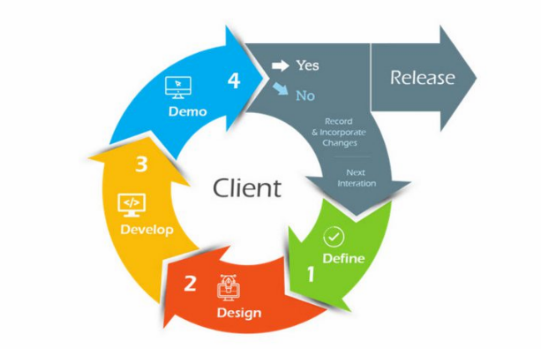

*"Figure 6 presents the Agile Development Lifecycle. This figure shows how planning, development, testing, and deployment were iteratively completed."*

**Scrum Framework:**

Scrum is basically a framework under Agile methodology, which manages development using well-defined roles, events, and artifacts. Emphasis is laid forth on sprints-the time-boxed iterations, combined with daily interaction of the team and additions made to continual improvement through the help of sprint reviews and retrospective.

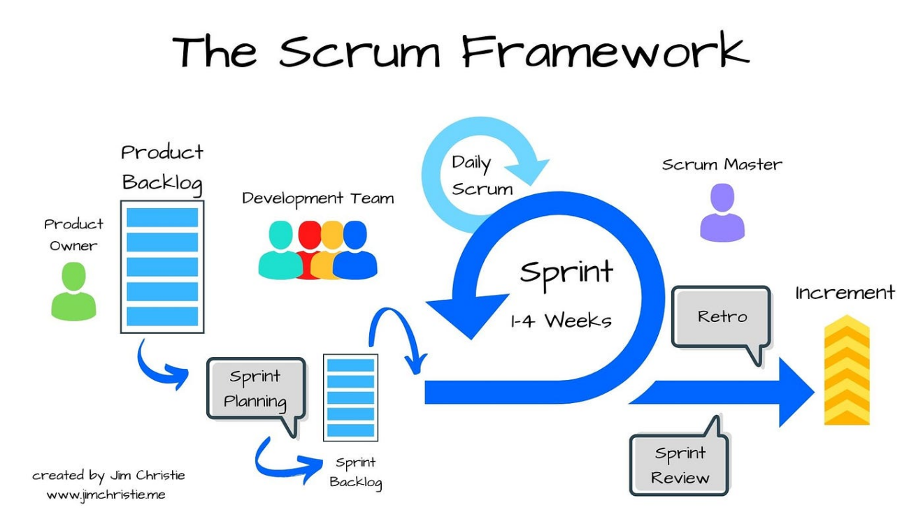

*"Figure 7: Iterative process of the Scrum Framework (Medium, n.d.)."*

**Research Design**

The system development of CLIRDEC: PRESENCE will follow developmental research design. In this case, the design will aim to develop, improve and perfect a smart attendance monitoring solution through a cyclic and iterative process whereby real-world feedback is incorporated. This design will go through several crucial phases: planning, system design, prototype, pilot testing and finally deployment, with evaluation and refinement occurring continuously throughout the process. This method guarantees their suitability for the operational requirements of the CLIRDEC building under the College of Engineering.

## System Architecture/Conceptual Framework

## System Architecture

## The System Architecture Diagram presents an overview of what the core components of CLIRDEC: PRESENCE attendance monitoring system is all about, and how these core components are related in providing such functionality. From IoT hardware such as RFID readers and proximity sensors to the microcontroller (ESP32), all the way to a cloud database and a web-based dashboard, the flow has been outlined. The diagram describes the entry and exit points data capturing of student attendance, processing with microcontroller, and relaying for storage and retrieval in the back-end system setup. Such structural inspection becomes requisite in understanding how the system provides support for real-time attendance tracking, discrepancy validation, and automated reports within the CLIRDEC setting. Appendix A (Figure 1) presents this architectural layout in detail.

**Conceptual Framework**

This study adopts the Input–Process–Output (IPO) model as the foundation for the design and development of the CLIRDEC: PRESENCE – Proximity and RFID-Enabled Smart Entry for Notation of Classroom Engagement. The framework outlines the flow of the project from identifying requirements through implementation, leading to a functional solution for automating classroom attendance.

**PROCESS**

**Validation Logic on ESP32:**

* Matches RFID taps with sensor triggers
* Verifies physical presence to prevent ghost attendance

**Session Management:**

* Instructor tap-in initializes session
* Only valid logs within active sessions are accepted

**Wi-Fi Communication:**

* Data securely transmitted to a cloud-based database

**Backend Processing:**

* Stores logs
* Flags mismatches
* Prepares structured data for frontend

**Role Based Access:**

* Admin and Faculty have different access privileges

**INPUT**

**Student RFID Card Taps** (Tap-IN and Tap-OUT)

**Proximity Sensor Activation** (to detect if a person is physically present)

**Instructor RFID Tap-IN/OUT** (to open/close session)

**Time and Location Data** (based on tap timestamp and sensor location)

**OUTPUT**

**Realtime Attendance Logs** (visible via the web dashboard)

**Automatically Generated Attendance Reports** (per session/class)

**Ghost Attendance Flags or Warnings**

**User Management and System configuration Panel** (Admin Only)

*"Figure 2 shows the System Architecture Diagram, illustrating how IoT devices, backend logic, and the database work together for real-time attendance tracking.*

**The Entity Relationship Diagram (ERD)**

The ERD illustrates the structure of the database designed specifically for the CLIRDEC: PRESENCE attendance monitoring system. It consists of eight primary tables: students, professors, classrooms, class_sessions, attendance_logs, tap_events, body_count_logs, and discrepancy_flags. The students table stores information such as “student_id” (primary key), “first_name”, “last_name”, “rfid_code”, “course”, and “year_level”. The professors table records faculty data including “professor_id”, “name”, “department”, and “rfid_code”. Classrooms are defined in the classrooms table, with fields such as “room_id”, “room_name”, “building”, and “capacity”. Class sessions are logged in the class_sessions table, which contains “session_id” (primary key), “class_code”, “professor_id”, “room_id”, “schedule_date”, “start_time”, and “end_time”.

Attendance-related data is handled across three tables. The attendance_logs table captures student check-ins using “log_id” (primary key), linking to both “student_id” and “session_id”, and includes “time_in”, “time_out”, and “status”. The tap_events table tracks RFID activity with fields such as “tap_id”, “rfid_code”, “timestamp”, “tap_type”, “sensor_validation”, and “location”. The body_count_logs table logs sensor-detected presence per session, storing “count_id”, “session_id”, “timestamp”, and “body_count”. Lastly, the discrepancy_flags table identifies mismatches between RFID logs and sensor data, with entries defined by “flag_id”, “session_id”, “student_id”, “flag_type”, and a “description” of the anomaly. This structure supports secure, automated, and verifiable attendance tracking tailored for the academic environment of CLSU.

**Flowchart**

The flowchart diagram provides a visual representation of the operational workflow of the CLIRDEC: PRESENCE attendance monitoring system. It outlines the sequential interactions among key components including the professor, student, RFID readers, proximity sensors, and backend validation logic during an active class session. The diagram emphasizes how the system manages RFID-based tap events, sensor-based presence validation, entry and exit logging, and final discrepancy checks. This structured flow helps illustrate how automated attendance tracking is carried out from session initialization to report generation. The flowchart, therefore, can be used as a reference for understanding the behavior of the system, thus providing clues as to whether data accuracy is observed, giving hints as to where optimization may be required, and directing system development thereafter. This is elaborated in Appendix A (Figure 4).

**Use-Case Diagram**

This diagram illustrates the core functionalities of the CLIRDEC: PRESENCE – IoT Attendance Monitoring System, developed to support accurate, automated, and role-based classroom attendance tracking at Central Luzon State University. The system is divided into three main actors: administrator, faculty, and student. Administrators are able to manage classrooms, set system configurations, manage user accounts, monitor real-time attendance dashboards, and log discrepancies caused by mismatches between RFID and proximity sensor data. Faculty members create and end class sessions using their RFID credentials. They access the class-specific dashboards, check attendance records, and generate attendance reports. Students tap RFID cards while entering and exiting classrooms, presence being validated by motion sensors. The system also has an automated discrepancy alert mechanism that raises discrepancies for administrative review. All actor interactions and system processes make the use-case diagram shown in Appendix A (Figure 5).

**Development Tools and Technologies**

The development of the CLIRDEC: PRESENCE – Proximity and RFID-Enabled Smart Entry for Notation of Classroom Engagement will utilize both hardware interfacing and software implementation tools and technologies to support automated attendance tracking and real-time monitoring:

* **Programming Languages:** During system development, the project will majorly use Python, HTML, CSS, and JavaScript.
* **Frameworks:** Python (for backend) and CSS (for frontend) will be the main frameworks in developing the proposed web-based dashboard.
* **Database:** MySQL, will be managed through PhpMyAdmin and hosted using the XAMPP server environment.
* **Development Tool:** Visual Studio Code will act as a primary integrated development environment (IDE) to write and organize system code.
* **Hardware:** Use of ESP32 microcontroller (otherwise Arduino Uno), RFID readers, RFID cards, and proximity sensors presenting any kind (like PIR sensors).
* **Hardware Requirements:** The system-based attendance application will also require a standard PC for development and testing, besides basic IoT stuff like ESP32 or Arduino Uno, RFID modules, and motion sensors, to get this application working for real-time attendance-oriented solution.

**Algorithms and Techniques**

The CLIRDEC: PRESENCE - Proximity and RFID-Enabled Smart Entry for Notation of Classroom Engagement will utilize the following algorithms and techniques to ensure accurate attendance tracking and anomaly detection:

**RFID-Based Logging:** This method will capture at each entry and exit of the students with this method will read RFID card data and associates it with the specific session time when that card event occurred.

**Proximity Validation:** An actual presence will be detected via motion or infrared sensor during an RFID tap for a student entering or exiting the room so as to prevent ghost attendance.

**Discrepancy Detection Algorithm:** Will compare RFID logs with sensor body counts. If a student taps their RFID but no physical body is detected or if the sensor detects a body with no corresponding RFID tap the system will flag a discrepancy for faculty and administrator review.

**Time Window Validation:** Will validates the log for tap-in and tap-out within the time assigned for that session, thus eliminating early or late unauthorized entry marking as valid attendance.

Last but not least, Data Integrity Checks: it will check the complete and correct formatting of RFID inputs, timestamps, and sensor logs before storing in the database.

**Data Integrity Checks:** Verifies that RFID inputs, timestamps, and sensor logs are complete and correctly formatted before being stored in the database.

**Implementation Process**

The Agile methodology will be used of SCRUM framework for developing CLIRDEC: PRESENCE - IOT Attendance Monitoring System in two-week sprints. Such an arrangement renders the team flexible enough to receiving feedback during prototyping and testing periods from the faculty members and user system. Continuous refinements can be achieved through iterative development cycles regarding features like attendance validation, reporting, and discrepancy handling making sure that they effectively address real classroom needs during the lifecycle of the project before coming up with the final version.

**Project Phases**

**Requirements Gathering**

* The project's first step will involve gathering functional and technical requirements from the faculty and staff of the CLIRDEC through interviews, consultations, and classroom observation to better understand the existing attendance processes and areas for improvement.
* The major activities involve system requirements such as RFID integration, proximity validation, dashboards, and report generation.

**System Design**

* The system architecture, including entity relationship diagrams (ERDs), data flow diagrams, and user interface wireframes, will now be designed.
* The MySQL schema shall be designed to house student records, class sessions, attendance logging, and discrepancy tracking.
* Wireframes and layout mockups will illustrate how the system behaves during RFID tap logging with dashboard monitoring and report generation.

**Development**

* The development phase will take place in building the system in Phython for the backend, HTML, CSS, and JavaScript (Bootstrap) for the frontend.
* Development will follow an Agile approach in two-week sprints so that any necessary coding, debugging, and feature enhancement can take place iteratively with feedback from CLIRDEC faculty.

**Testing**

* This will be the stage where multiple levels of testing will be employed such as testing units on the backend functions for attendance logging and sensor triggers, integration tests on interactions with the database, and functional tests on dashboard modules.
* Usability testing will be also conducted with faculties to assess system responsiveness, accuracy, and user-friendliness.

**Table 1:** Test Cases

|  |  |
| --- | --- |
| **Fields** | **Description** |
| Test Case ID | Unique identifier for the test case |
| Test Case Description: | Brief description of the test case’s purpose |
| Pre-conditions | List of conditions before executing the test case |
| Test Steps | List of actions to be performed during the test. |
| Test Data | Input data values required to execute the test case. |
| Expected Result | The anticipated outcome based on the test inputs and conditions. |
| Post Condition | The state of the system after executing the test. |
| Actual Result | The outcome observed after performing the test steps. |
| Status | Indicates whether the test case passed or failed. |
| Project Name | The title of the project under which the test is conducted. |
| Module Name | The specific module or component being tested. |
| Reference Document | Related documents or specifications that support the test case. |
| Created By | Name of individual who created the test case. |
| Date of Creation | The date when the test case was written. |
| Reviewed By | Name of the person who reviewed and validated the test case. |
| Date of Review | The date when the test case was reviewed. |
| Executed By | The person who performed the test case execution. |
| Date of Execution | The actual date the test was executed. |
| Comments | Additional remarks encountered during testing. |

**Deployment**

* This phase included configuring the system in a test environment using XAMPP and PhpMyAdmin, integrating the hardware setup (RFID reader, sensors), and deploying the system for pilot use in selected CLIRDEC classrooms.
* Final validations will be conducted with faculty to identify deployment issues and confirm system readiness for broader use.

**Roles:**

**1. Client (CLIRDEC building Coordinator):** The primary stakeholder and end user for the system. The coordinator will interview the existing attendance workflows and validate system requirements needed by academic and administrative needs of the College of Engineering.

**2. Scrum Master:** Facilitated the development process, monitored scrum practices, eliminated obstacles, and set sprint goals.

**3. Development Team:** Responsible to design, develop, test, and deploy the CLIRDEC: PRESENCE system. This includes prototyping the system, hardware-software integration (RFID + sensors) front-end-back-end development and report generation features.

**Events:**

**1. Sprint:** A fixed two-week development cycle to implement specific features or improvements. Every sprint gives incremental updates to system modules-such as RFID logging, dashboard integration, or discrepancy detection.

**2. Sprint Planning:** It involved the members of the team to discuss the priority tasks that were generated through faculty and stakeholder feedback and aligned these goals to project goals and organized deliveries into work units.

**3. Daily Scrum (Stand-up):** A brief daily meeting in which all team members report on progress made, plan the day's activities, and discuss any impediments to development.

**4. Sprint Review:** Completed Features at the end of every sprint are to be demonstrated to the CLIRDEC coordinator and select faculty members. Feedback will be collected to refine functionality and improve user interface.

**5. Sprint Retrospective:** The former development team reflects during the sprint retrospective because this is the event that assesses what went well or what could be improved and plans on how to better future sprints.

**Artifacts:**

**Product Backlog:** A prioritized list of all required features, functionalities, and improvements needed in the system derived from discussions with the CLIRDEC faculty as well as the program coordinator. The important components included in it are logging of attendance by RFID, proximity-based validation, tracking of discrepancies, real-time dashboards, and automated reports.

**Sprint Backlog:** The selected items from the product backlog that were refined for execution within a defined two-week cycle of sprint work. This sprint backlog reflects the technological tasks and outputs that the development team committed to completing-such as sensor integration, UI updates, or database structure. The sprint backlog is one of the key artifacts created in scrum to identify the progress of the whole team.

**Increment:** The completed and functional output of each sprint that contributes to the working CLIRDEC: PRESENCE system. Each increment will include tested and integrated features such as real-time attendance recording, discrepancy detection mechanisms, attendance dashboards, and faculty reporting tools.

**Data Collection and Processing**

The CLIRDEC: PRESENCE system will involve data collection and processing to monitor student attendance, validate physical presence, and generate accurate reports for classroom sessions in real time.

**Data Sources:**

* **RFID Tap Logs:** The system will collect data from each student’s RFID tap-in and tap-out activity, capturing student ID, timestamp, and classroom/session ID.
* **Sensor Logs:** Proximity or motion sensors placed at classroom entry and exit points detect actual movement, providing presence validation to confirm that each tap corresponds to a real person entering or exiting.
* **Session Schedules:** Faculty-defined schedules and session data will be stored in the system to determine whether student entry/exit occurred within the valid time window.

**Data Processing:**

* Tap events will be matched with sensor data to validate physical presence.
* Attendance status will be determined by evaluating RFID logs and session timing: students will be tagged as Present, Late, or Absent accordingly.
* Discrepancies will be automatically flagged when mismatches occur between RFID and sensor data (e.g., a tap with no physical body detected or vice versa).
* Aggregated attendance records will be compiled to generate class attendance summaries, individual student logs, and irregularity reports.

**Statistical Treatment:**

* Descriptive Statistics: Adopted in elaborating with attendance data per session, i.e., number of students marked Present, Late, or Absent.
* Comparative Analysis: Evaluates attendance accuracy and faculty reporting efficiency before and after implementing CLIRDEC: PRESENCE to measure improvements in monitoring and automation.
* Trend Analysis: Identifies patterns in absenteeism, entry/exit behavior, and sensor discrepancies across time periods to inform faculty interventions and improve attendance policies.

### Sampling Method:

Purposive sampling will be employed as the chosen sampling method to ensure that data will be collected from individuals directly involved in classroom operations within the CLIRDEC building under the College of Engineering. Participants will include faculty and student members associated with regularly scheduled sessions in laboratories and classrooms. They are chosen based on their firsthand experience on conventional attendance monitoring methods, thereby, their reflections become particularly useful and applicable about evaluating the CLIRDEC: PRESENCE system in terms of functionality, usability, and effectiveness.

**Testing and Evaluation**

The reliability, usability, and effectiveness of the CLIRDEC: PRESENCE - Proximity and RFID-Enabled Smart Entry for Notation of Classroom Engagement will be ensured through a comprehensive testing and evaluation process conducted throughout the project’s development cycle.

**Testing Strategies:**

* **Unit Testing:** Each system component such as RFID tap detection, proximity sensor input, session activation, and timestamp recording will be individually tested to verify correct functionality, accuracy, and responsiveness.
* **Integration Testing:** The integration between hardware and software modules (e.g., RFID + proximity sensor + database logging) will be tested to ensure data consistency across components and proper communication between the frontend dashboard and backend storage.
* **Usability Testing:** Faculty members and selected CLIRDEC students will be engaged to evaluate the system interface and overall experience. These sessions will help determine the system’s usability, efficiency in logging attendance, and ease of generating reports.

**Evaluation Models**

**ISO Standards**

Evaluation with respect to international software quality guidelines is particularly on functional suitability, usability, and reliability in regard to ISO/IEC standards. These standards will ensure that the CLIRDEC: PRESENCE system meets accepted benchmarks for effective deployment in an academic environment.

**Metrics**

Usability testing will involve the collection of user feedback and satisfaction metrics through observation and short feedback forms distributed to faculty members. These metrics will help in evaluating user experience regarding interface clarity, response time of the system, and ease of accomplishing tasks during real-time class sessions.

**Ethical Considerations**

The development team shall abide by ethical principles for the entire duration of this project. Feedback regarding the usage of the system will be collected only after user consent. Moreover, during development and testing, only simulated or anonymized student data will be used so as to guarantee privacy.

**Data Security**

All attendance data exchanged between system components will be secured through encrypted data transmission protocols. Secure database access controls will be implemented to prevent unauthorized access and manipulation.

**Privacy Compliance**

The system will comply with institutional data protection policies and assure students' and faculty members' confidentiality in personal data. Sensitive attendance records will be available and visible only to authorized users such as faculty and administration.

**Data Usage:**

All these data collected will only be strictly used for classroom attendance management and academic monitoring purposes. Faculty users will be briefed as to how the data will be handled regarding transparency, consent, and accountability.

APPENDICES

**Appendix A**

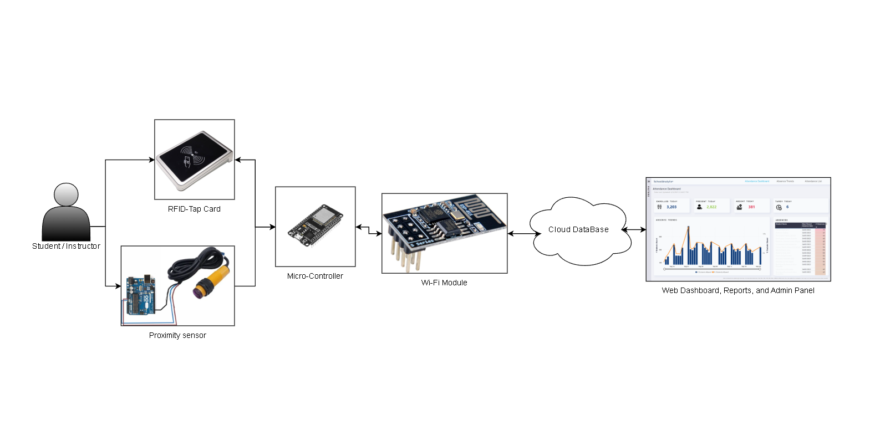

*Figure 1: system architecture diagram*

**Appendix A**

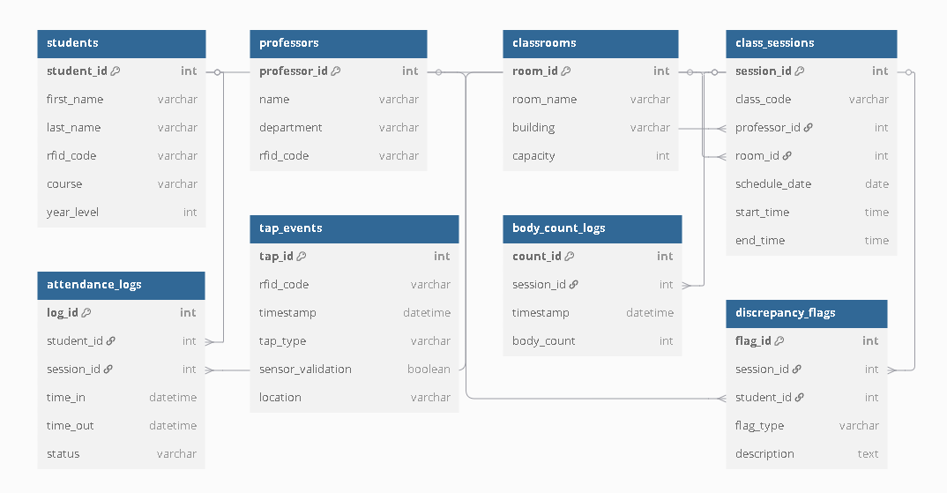

*Figure 3: entity related diagram*

**Appendix A**

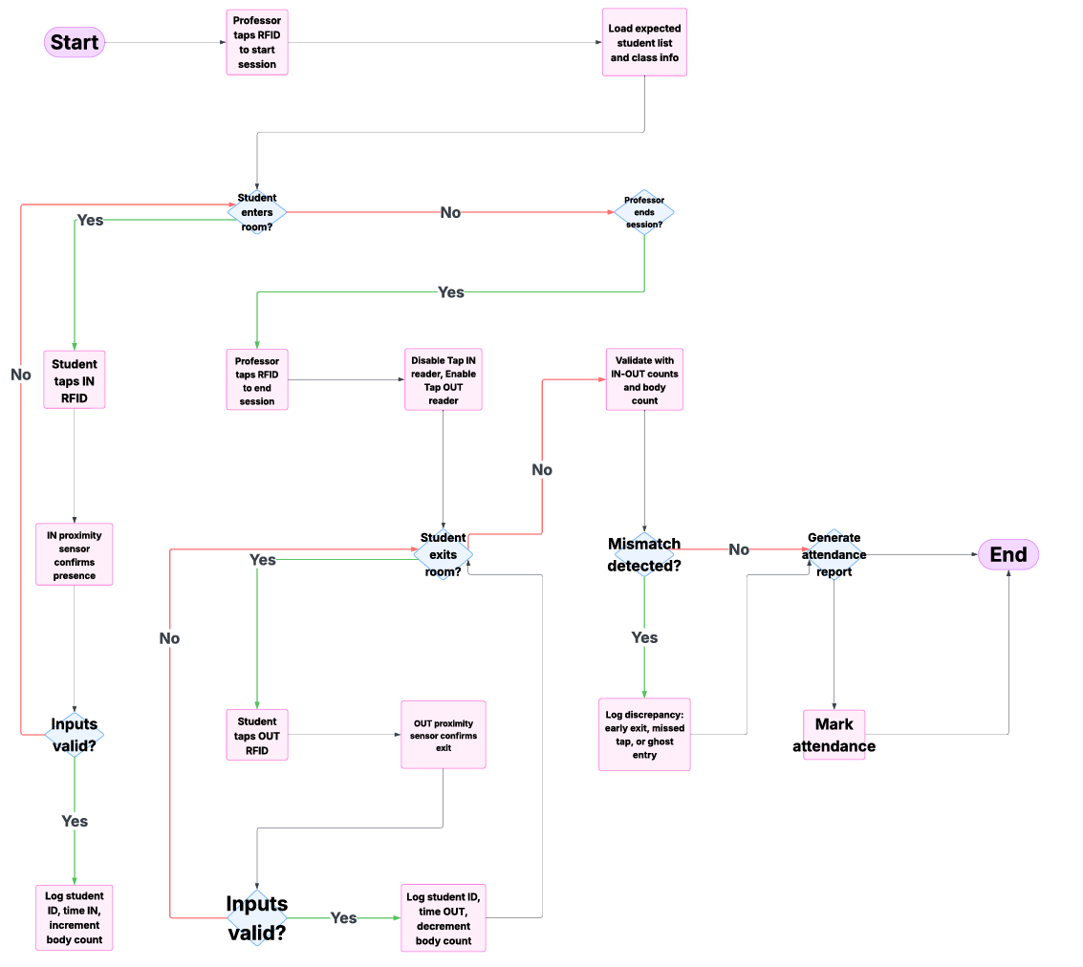

*Figure 4: flowchart*

**Appendix A**

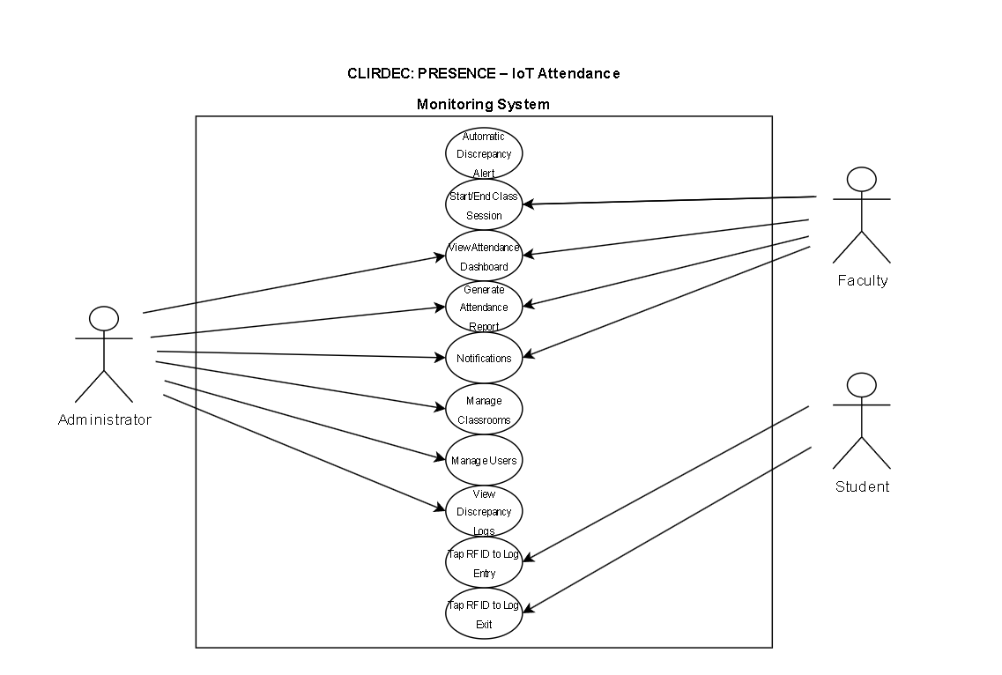

*Figure 5: use-case diagram*

**Appendix B**

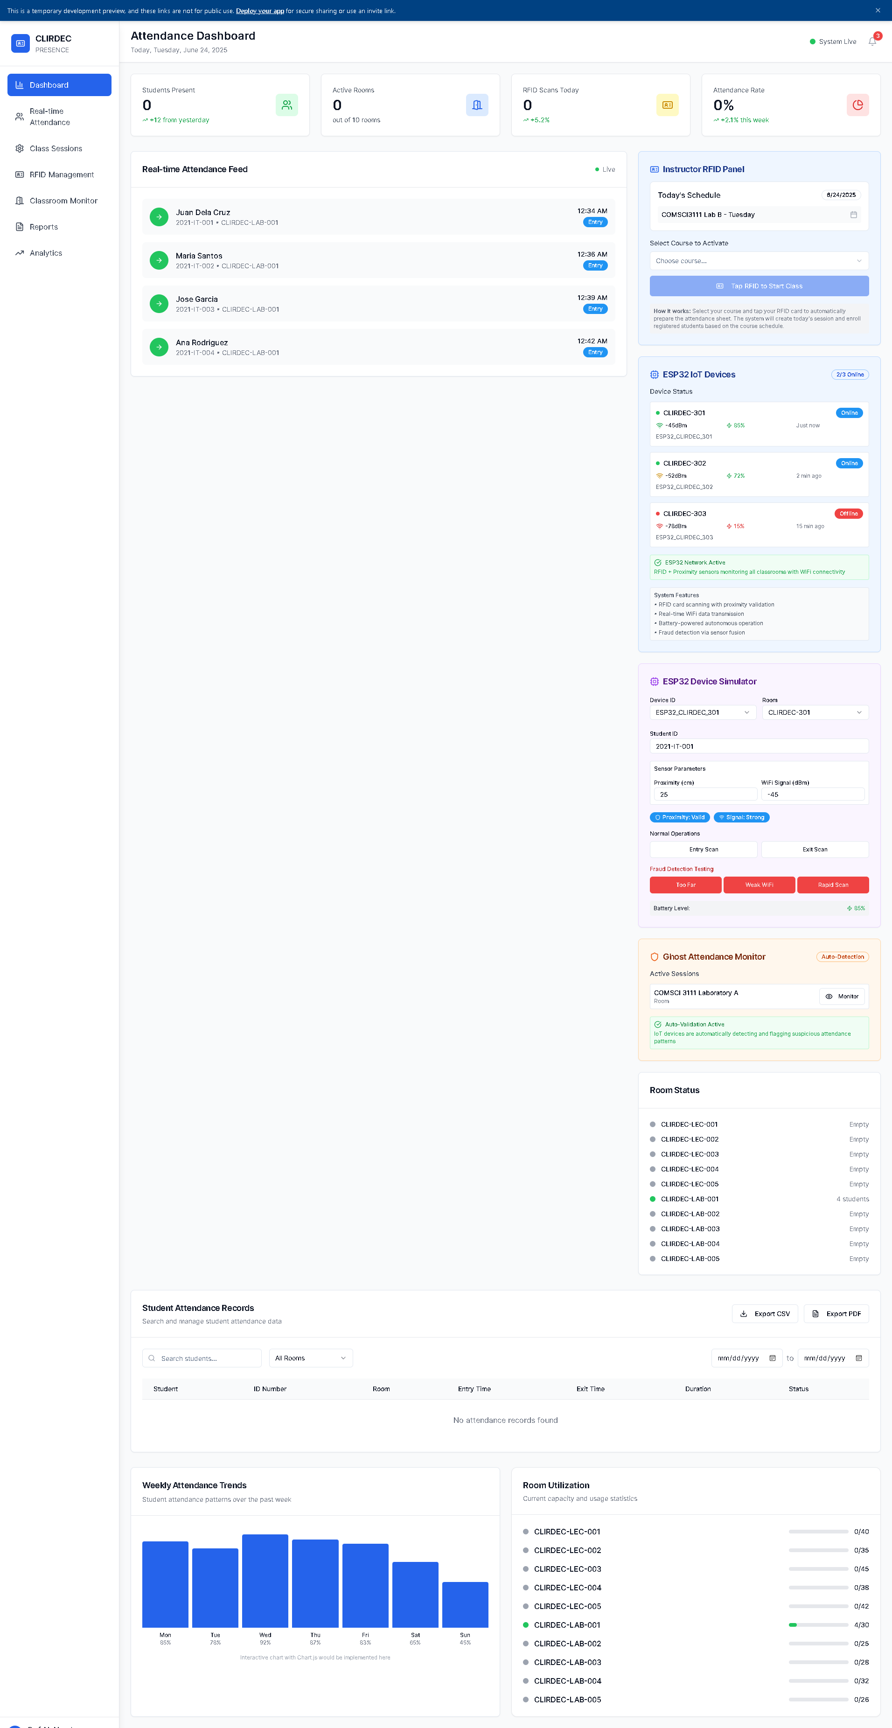

*Figure 6: PRESENCE Dashboard*

**Appendix B**

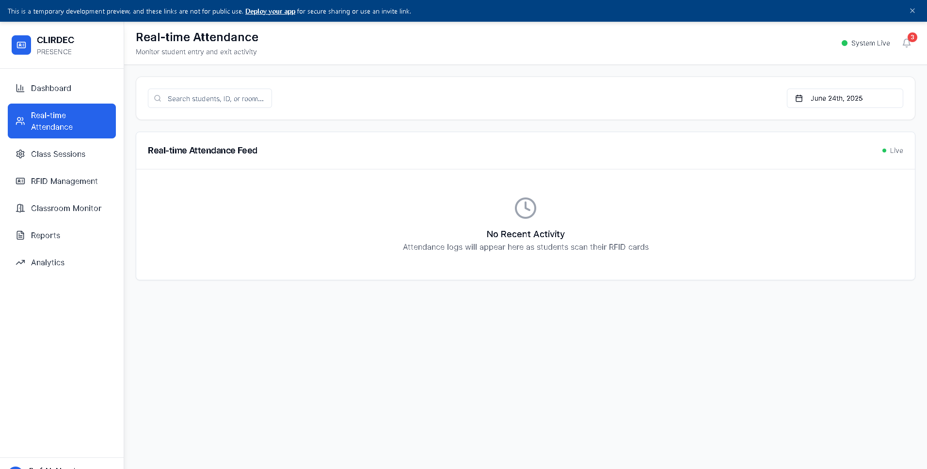

*Figure 7: PRESENCE Real-time Attendance*

**Appendix B**

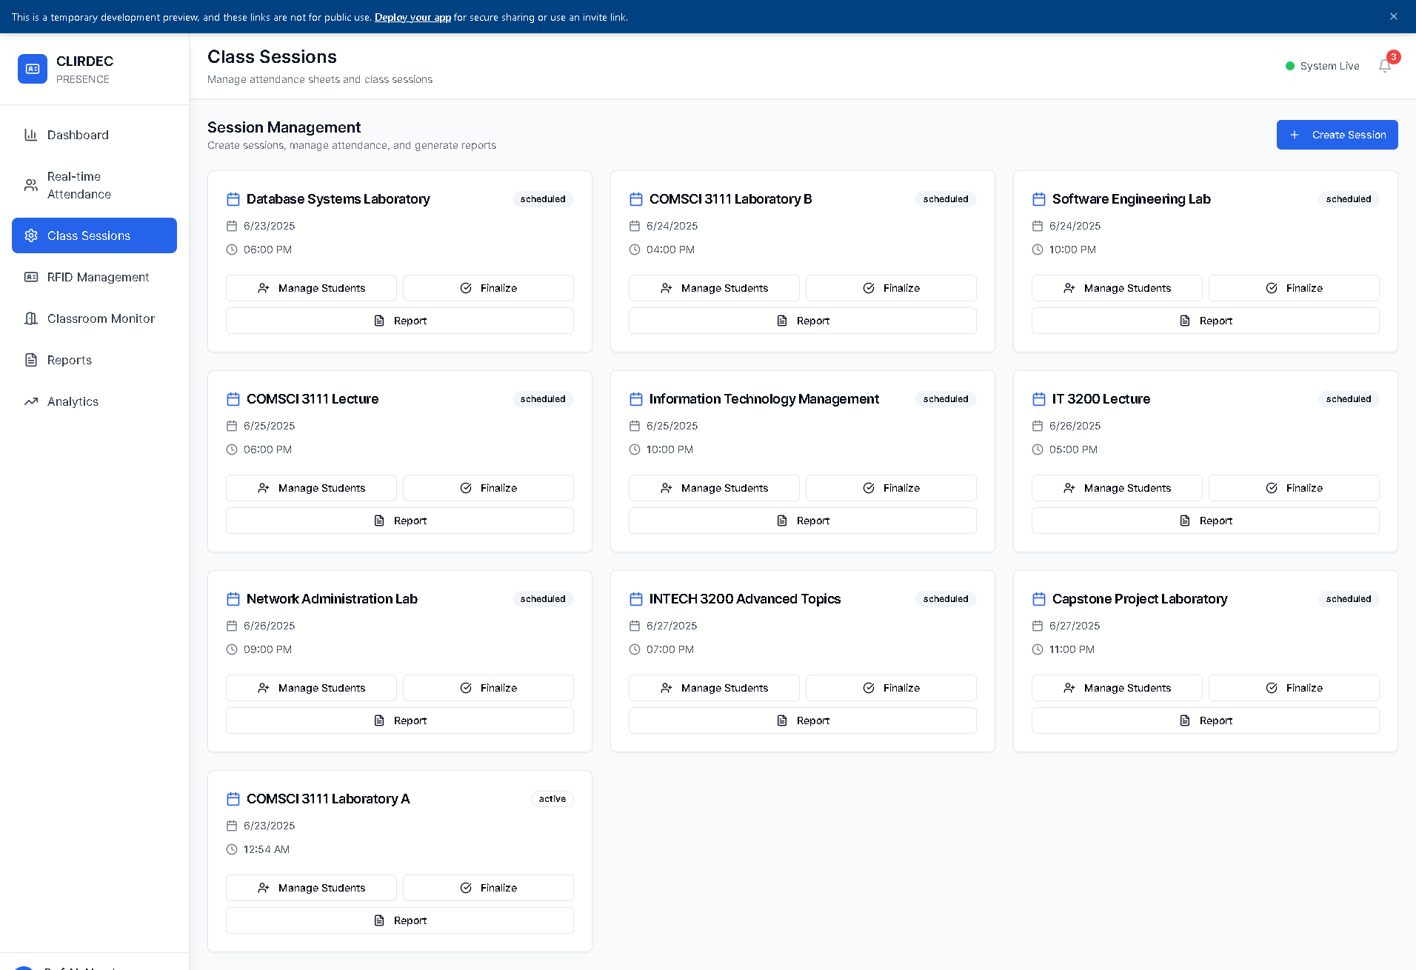

*Figure 8: PRESENCE Class Sessions*

**Appendix B**

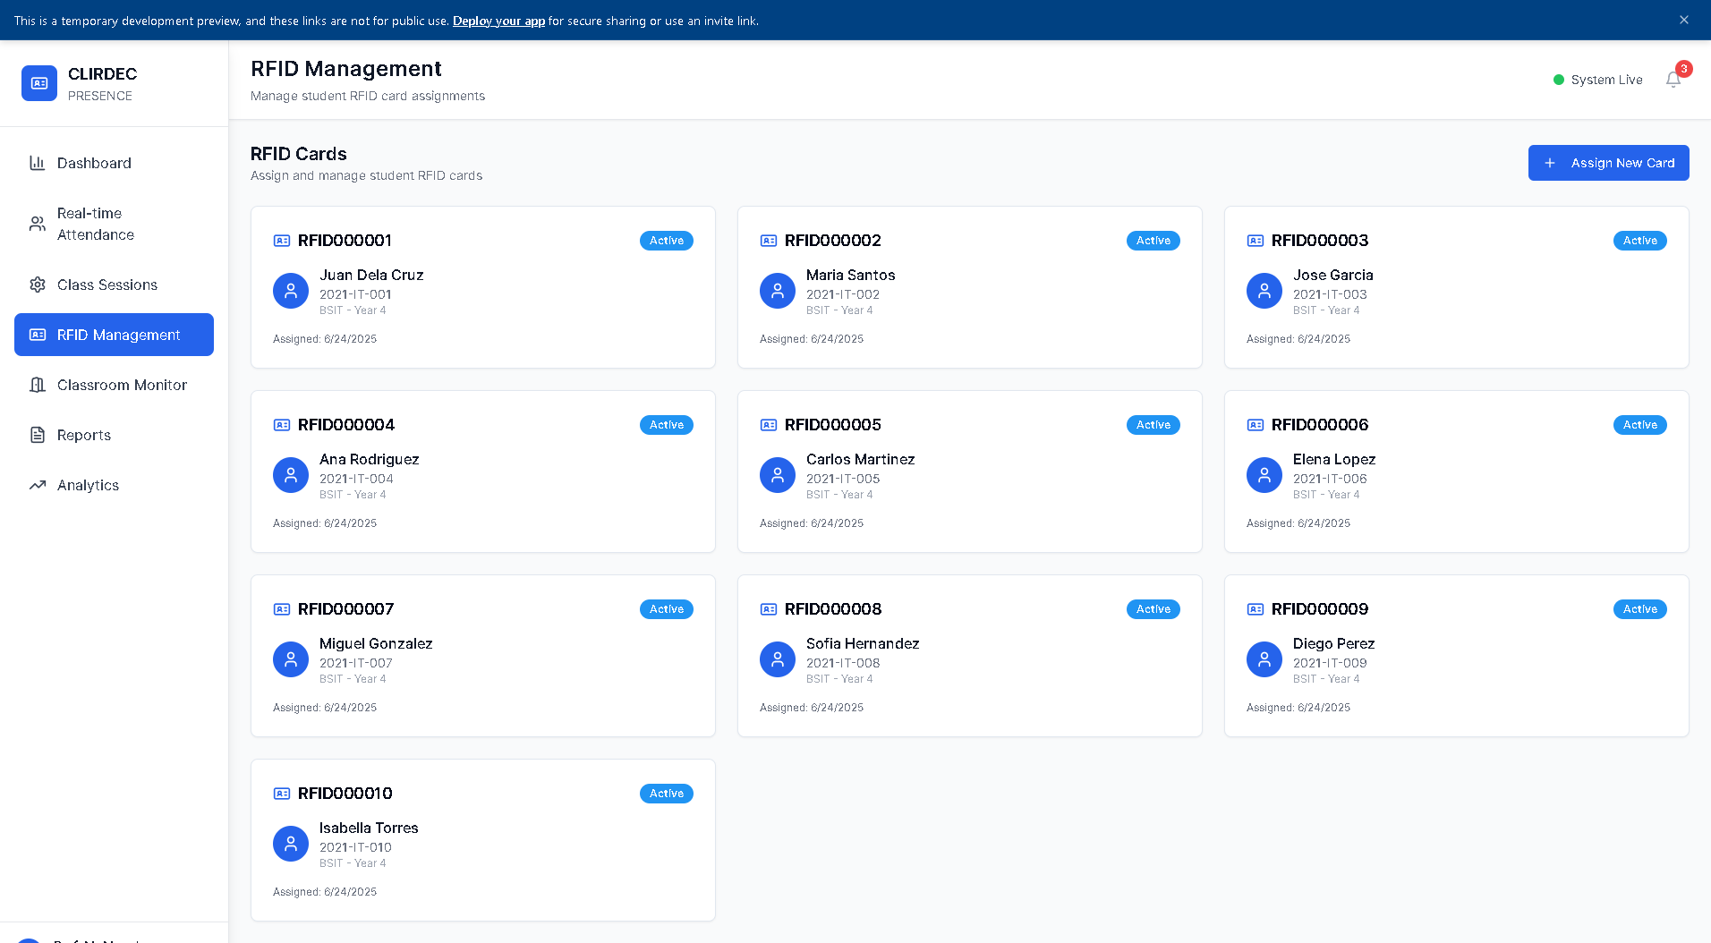

*Figure 9: PRESENCE RFID Management*

**Appendix B**

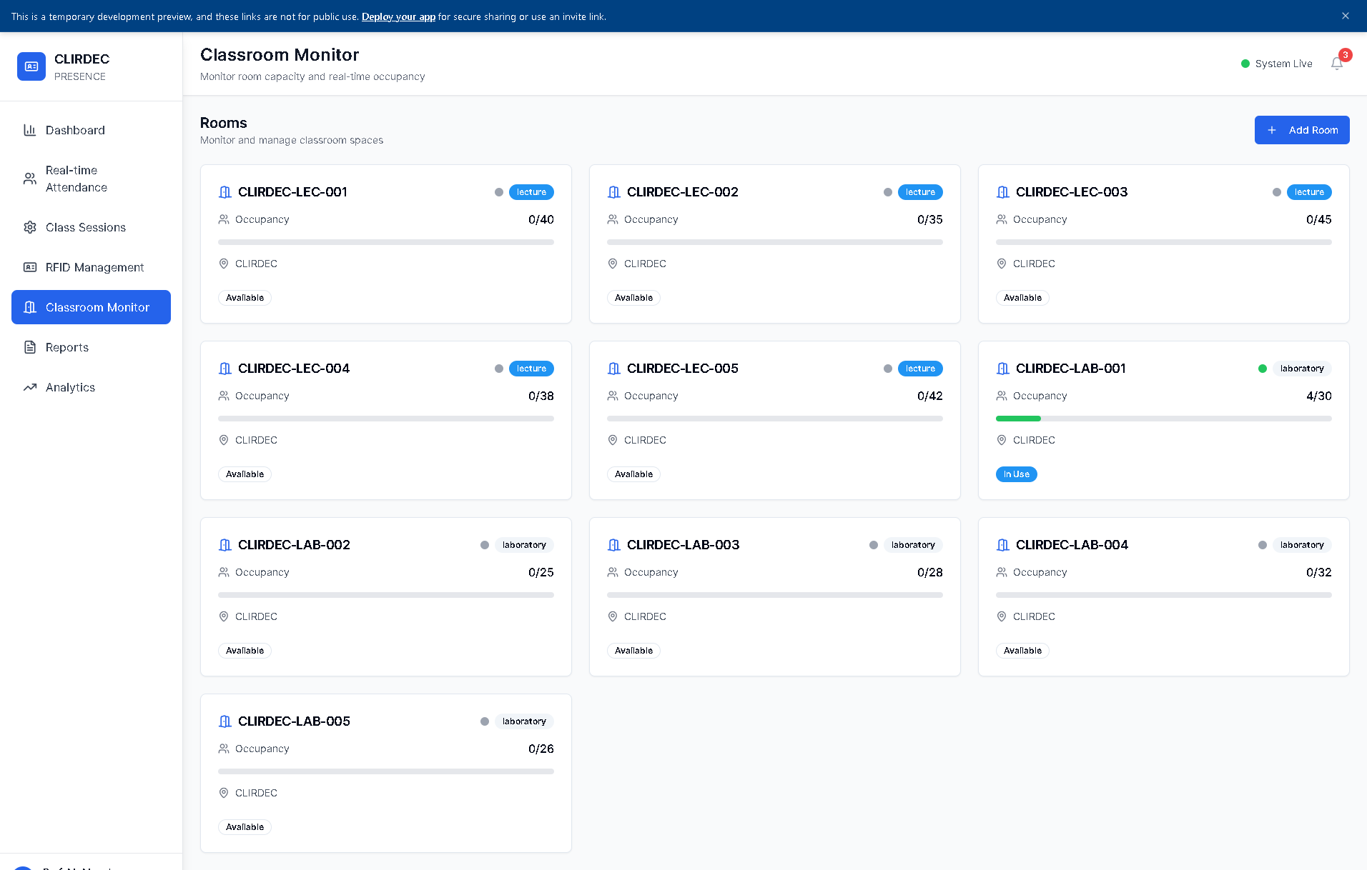

*Figure 10: PRESENCE Classroom Monitor*

**Appendix B**

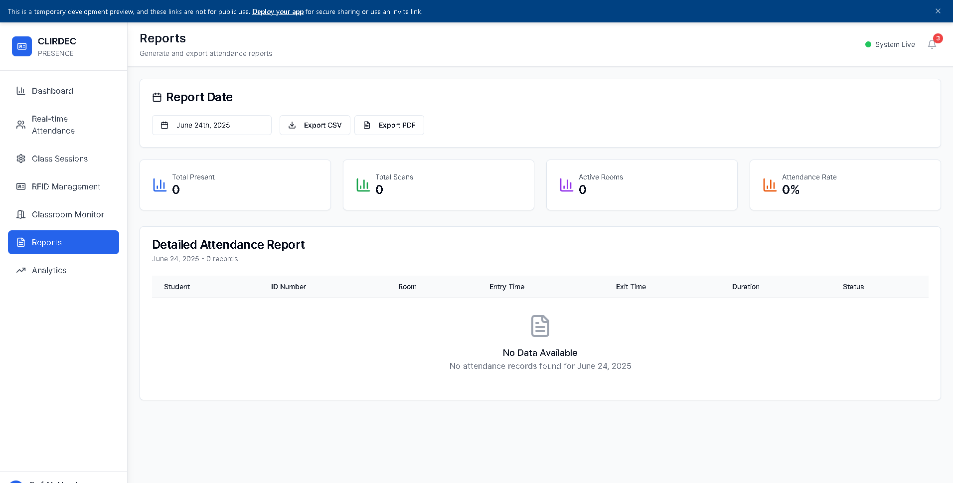

*Figure 11: PRESENCE Reports*

**Appendix B**

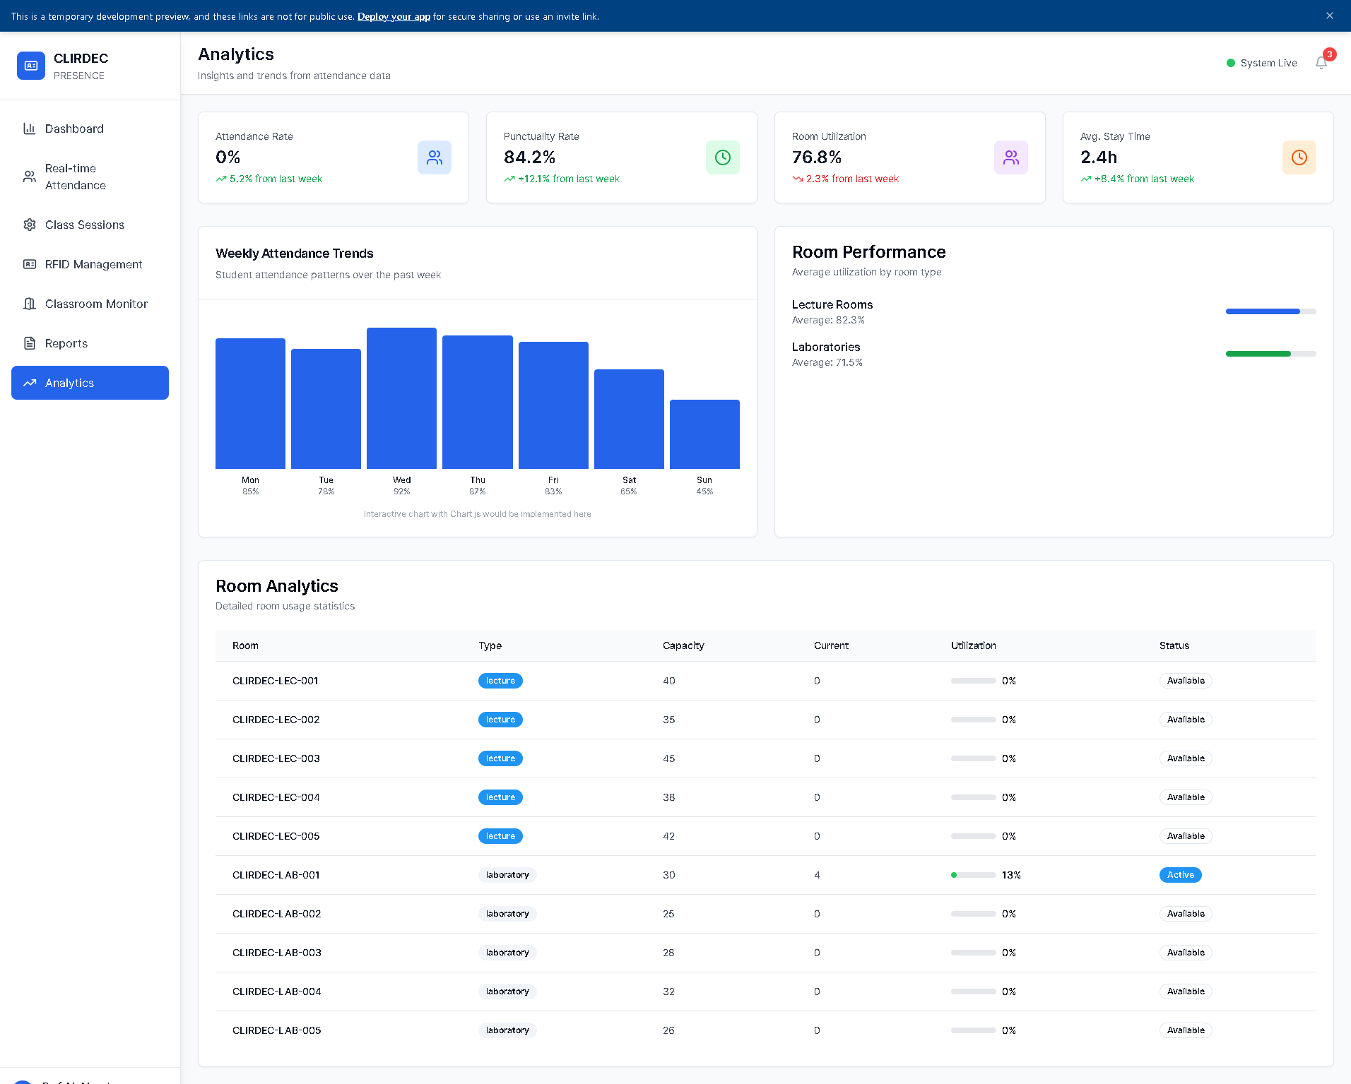

*Figure 12: PRESENCE Analytics*

**Appendix B**

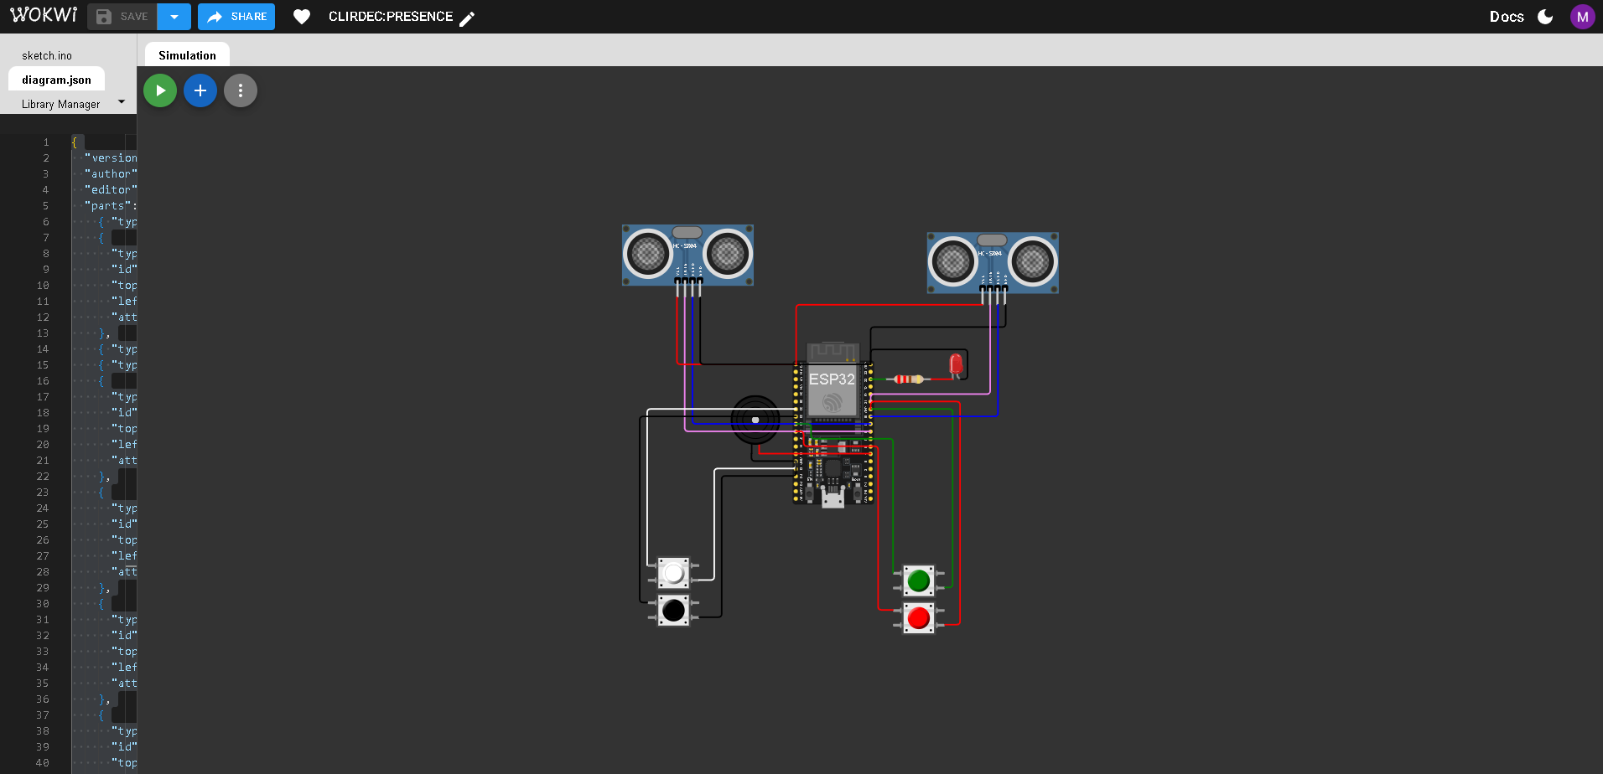

*Figure 13: PRESENCE IoT-Device*

References

Ahmed, S., & Mazri, T. (2023). Security approaches for smart campus. In *Lecture notes in networks and systems* (pp. 196–205). <https://doi.org/10.1007/978-3-031-26852-6_18>

Mylonas, G., Amaxilatis, D., Tsampas, S., Pocero, L., & Gunneriusson, J. (2019). A Methodology for Saving Energy in Educational Buildings Using an IoT Infrastructure. *2019 10th International Conference on Information, Intelligence, Systems and Applications (IISA)*, 1–7. <https://doi.org/10.1109/iisa.2019.8900707>

Nguyen, V. D., Van Khoa, H., Kieu, T. N., & Huh, E. (2022b). Internet of Things-Based Intelligent Attendance System: Framework, practice implementation, and Application. *Electronics*, *11*(19), 3151. <https://doi.org/10.3390/electronics11193151>

Samaddar, R., Ghosh, A., Sarkar, S. D., Das, M., & Chakrabarty, A. (2023). IoT & Cloud-based Smart Attendance Management System using RFID. *International Research Journal on Advanced Science Hub*, *5*(03), 111–118. <https://doi.org/10.47392/irjash.2023.020>

Zhao, M., Zhao, G., & Qu, M. (2022). College Smart Classroom attendance Management system based on Internet of things. *Computational Intelligence and Neuroscience*, *2022*, 1–9. <https://doi.org/10.1155/2022/4953721>

Krihsna, P. G., Subbarayudu, Y., Rao, K. M., Jyoshna, V., Aman, J., & Reddy, G. V. (2023). An Efficient, Novel, and Sustainable IoT-Based Approach for Attendance Detection through RFID Module and IR Sensor. E3S Web of Conferences, 430, 01096. <https://doi.org/10.1051/e3sconf/202343001096>

Hayati, N., & Nugraha, A. E. (2023). Design and implementation proximity based IoT for smart attendance System. *Buletin Pos Dan Telekomunikasi*, *21*(2), 16–31. <https://doi.org/10.17933/bpostel.v21i2.380>

Hussien, S. H. T., Farhana, H. a. R. N., Vinukumar, L., Alexander, C. H. C., & Sivakumar, S. (2024). Smart campus attendance and security systems: Leveraging IoT for enhanced efficiency. *AIP Conference Proceedings*, *3161*, 020153. <https://doi.org/10.1063/5.0229386>

Ishaq, K., & Bibi, S. (2023). IoT Based Smart Attendance System Using RFID: A Systematic Literature Review. *arXiv (Cornell University)*. <https://doi.org/10.48550/arxiv.2308.02591>

Valdez, C. J. H., Nivales, Y. M., Uy, R. J. R., & Montañez, J. J. F. (2024). TrackID: RFID-Based student monitoring system for accessing institutional campus. *2021 International Conference on Innovation and Intelligence for Informatics, Computing, and Technologies (3ICT)*, 427–434. <https://doi.org/10.1109/3ict64318.2024.10824565>

Shoewu, N. O. O., Akinyemi, N. L. A., Mumuni, N. Q. A., Ajasa, N. a. A., Folorunso, N. C. O., & Edozie, N. R. (2022). Development of a smart attendance system using near field communication (SMAT-NFC). *Global Journal of Engineering and Technology Advances*, *12*(2), 121–139. <https://doi.org/10.30574/gjeta.2022.12.2.0150>

Verma, S. S., Vargiya, P. V., Sharma, P., & Kumar, R. (2022). RFID based attendance marker. Poornima College of Engineering, Department of Electrical Engineering. Retrieved from <https://pce.poornima.org/NAAC/Re-DVV/1/1.3.2/1.3.2.5/1.3.2.5.4_EeneE/G-20%20RFID%20Based%20Attendance%20Marker.pdf>

Abellana, L. K. B., Amper, B. P., Bacol, D. M. P., & Carias, A. M. G. (2022). RFID attendance system for students using Arduino with GSM. Bohol Island State University, College of Engineering, Architecture, and Industrial Design. <https://doi.org/10.13140/RG.2.2.17639.97446>

Velasco, R. M. (2023). IoT security solutions for students’ laboratory with RFID-based attendance authentication. *Journal Name*, *5*, 23–32.

Cadungog, R. R., Nambong, R. L., Hontiveros, N. L., Tenebroso, M. B. C., & Serrano, M. R. (2024). Cite_Stema SA Atendansiya: Modernizing Cite Students Attendance System with RFID Technology. *International Journal of Computer Science & Engineering Survey*, *15*(2/3/4), 01–16. <https://doi.org/10.5121/ijcses.2024.15401>

Yumang, A. N., Padilla, D., Sejera, M., Pajarillo, A. C. U., Van Laurent B Palmiano, G., & Racho, M. M. F. (2017). Attendance checker for students of Mapúa University. *2021 IEEE 13th International Conference on Humanoid, Nanotechnology, Information Technology, Communication and Control, Environment, and Management (HNICEM)*, 1–3. <https://doi.org/10.1109/hnicem.2017.8269558>

Grefaldo, L. H., Jr., & Bausa, M. E. (2025). Attendance monitoring and records management system for Pilar National Comprehensive High School using face recognition. Global Scientific Journal, 13(2), 23–32. [https://www.globalscientificjournal.com/researchpaper/ATTENDANCE_MONITORING_AND_RECORDS_MANAGEMENT_SYSTEM_FOR_PILAR_NATIONAL_COMP COMPREHENSIVE_HIGH_SCHOOL_USING_FACE_RECOGNITION.pdf](https://www.globalscientificjournal.com/researchpaper/ATTENDANCE_MONITORING_AND_RECORDS_MANAGEMENT_SYSTEM_FOR_PILAR_NATIONAL_COMP%20COMPREHENSIVE_HIGH_SCHOOL_USING_FACE_RECOGNITION.pdf)

Bayani, A. D. D., Fabra, M. G., Joseph, V. M. C., Pelayo, C. J. A., Diloy, M. A., & Esberto, E. M. (2023). WeConnect: Class attendance monitoring system with the use of mobile tethering. In *Proceedings of the 2023 8th International Conference on Information and Education Innovations (ICIEI '23)* (pp. 126–129). Association for Computing Machinery. <https://doi.org/10.1145/3594441.3594462>

Saint Louis University. (n.d.). Privacy policy – Data Protection Office. <https://dataprotection.slu.edu.ph/privacy-policy-2/>